**EXPERIMENT - 6**

**AIM OF THE EXPERIMENT:**

To design and verify an Integrator using multisim

**APPARATUS REQUIRED:**

PC loaded with multisim software

**THEORY:**

**Integrator** is an operational amplifier circuit that performs the mathematical operation of **Integration**, that is we can cause the output to respond to changes in the input voltage over time as the op-amp integrator produces an output voltage which is proportional to the integral of the input voltage.

In other words the magnitude of the output signal is determined by the length of time a voltage is present at its input as the current through the feedback loop charges or discharges the capacitor as the required negative feedback occurs through the capacitor.

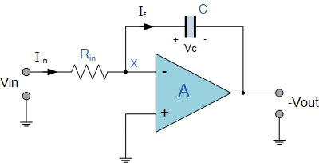

**VERIFICATION:**

Circuit Diagram

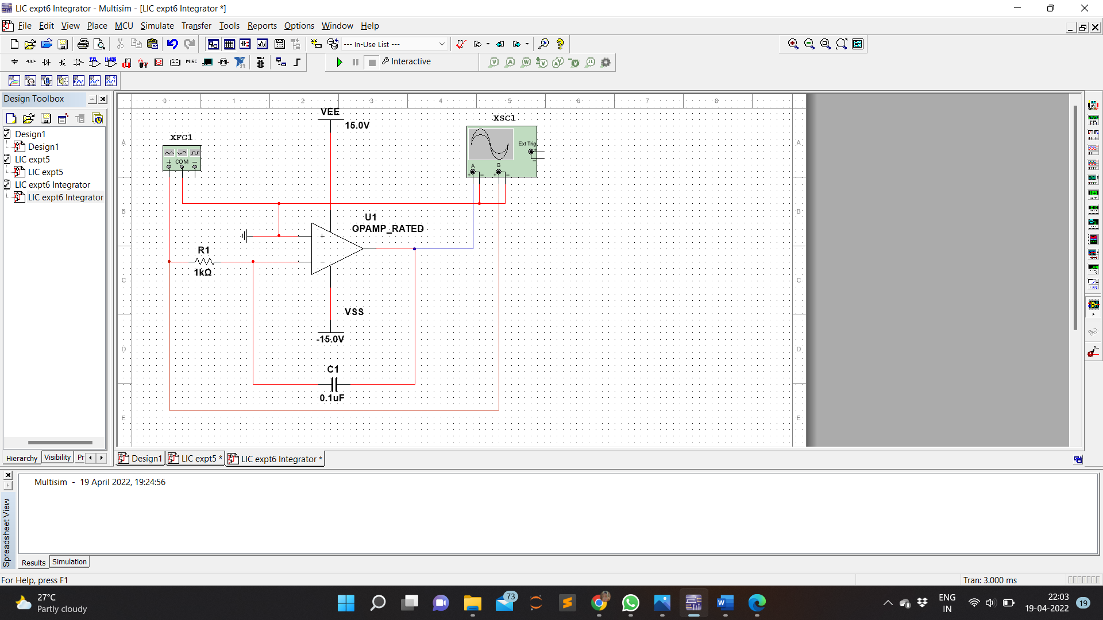

Input Voltage

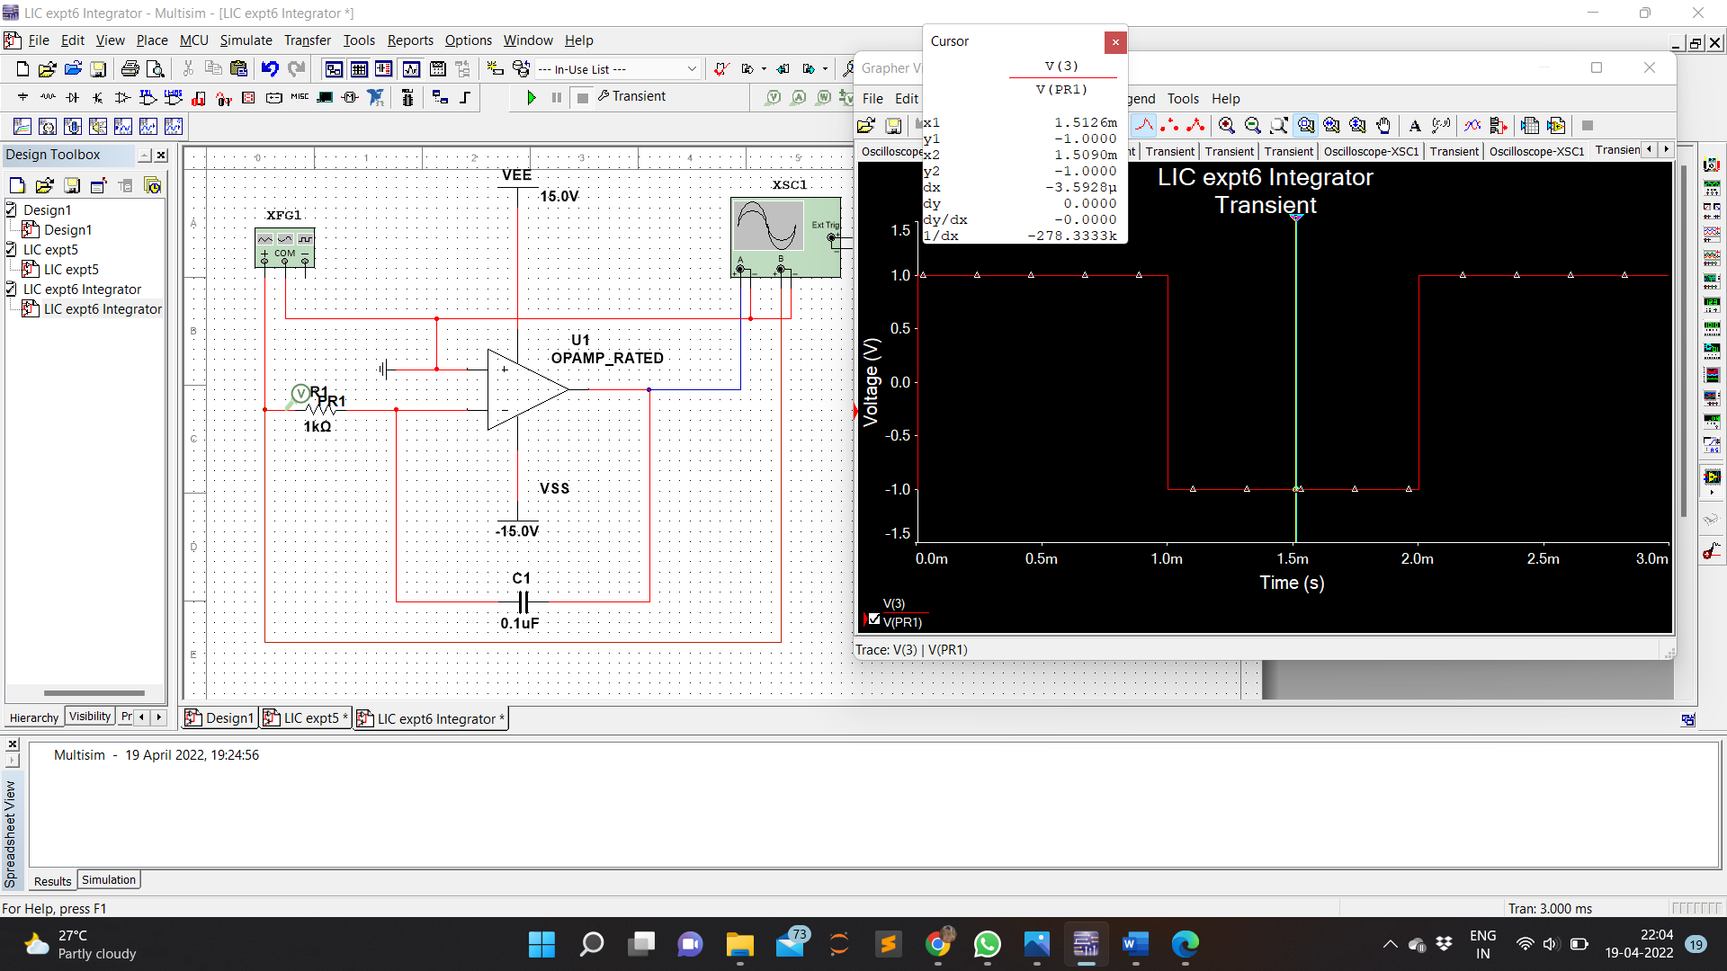

Output Voltage

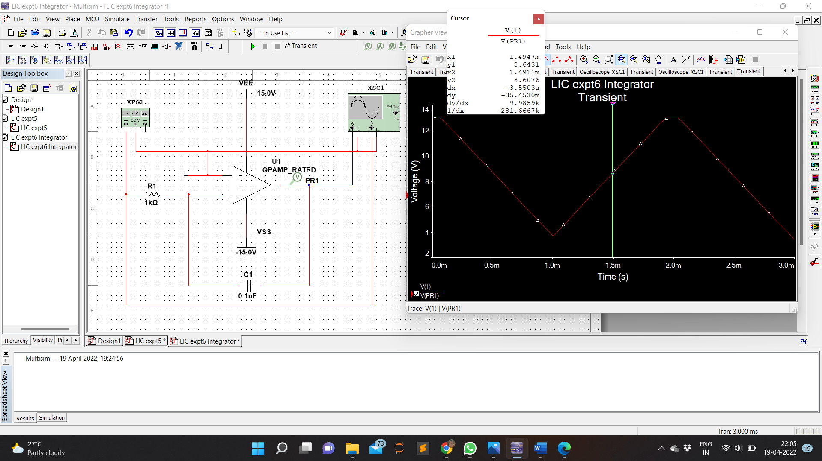

Waveform

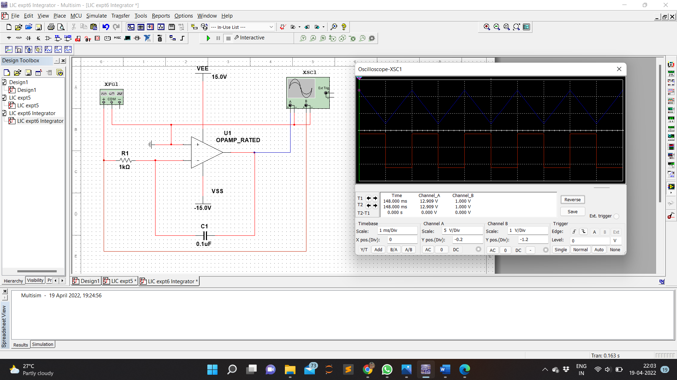

Calculation

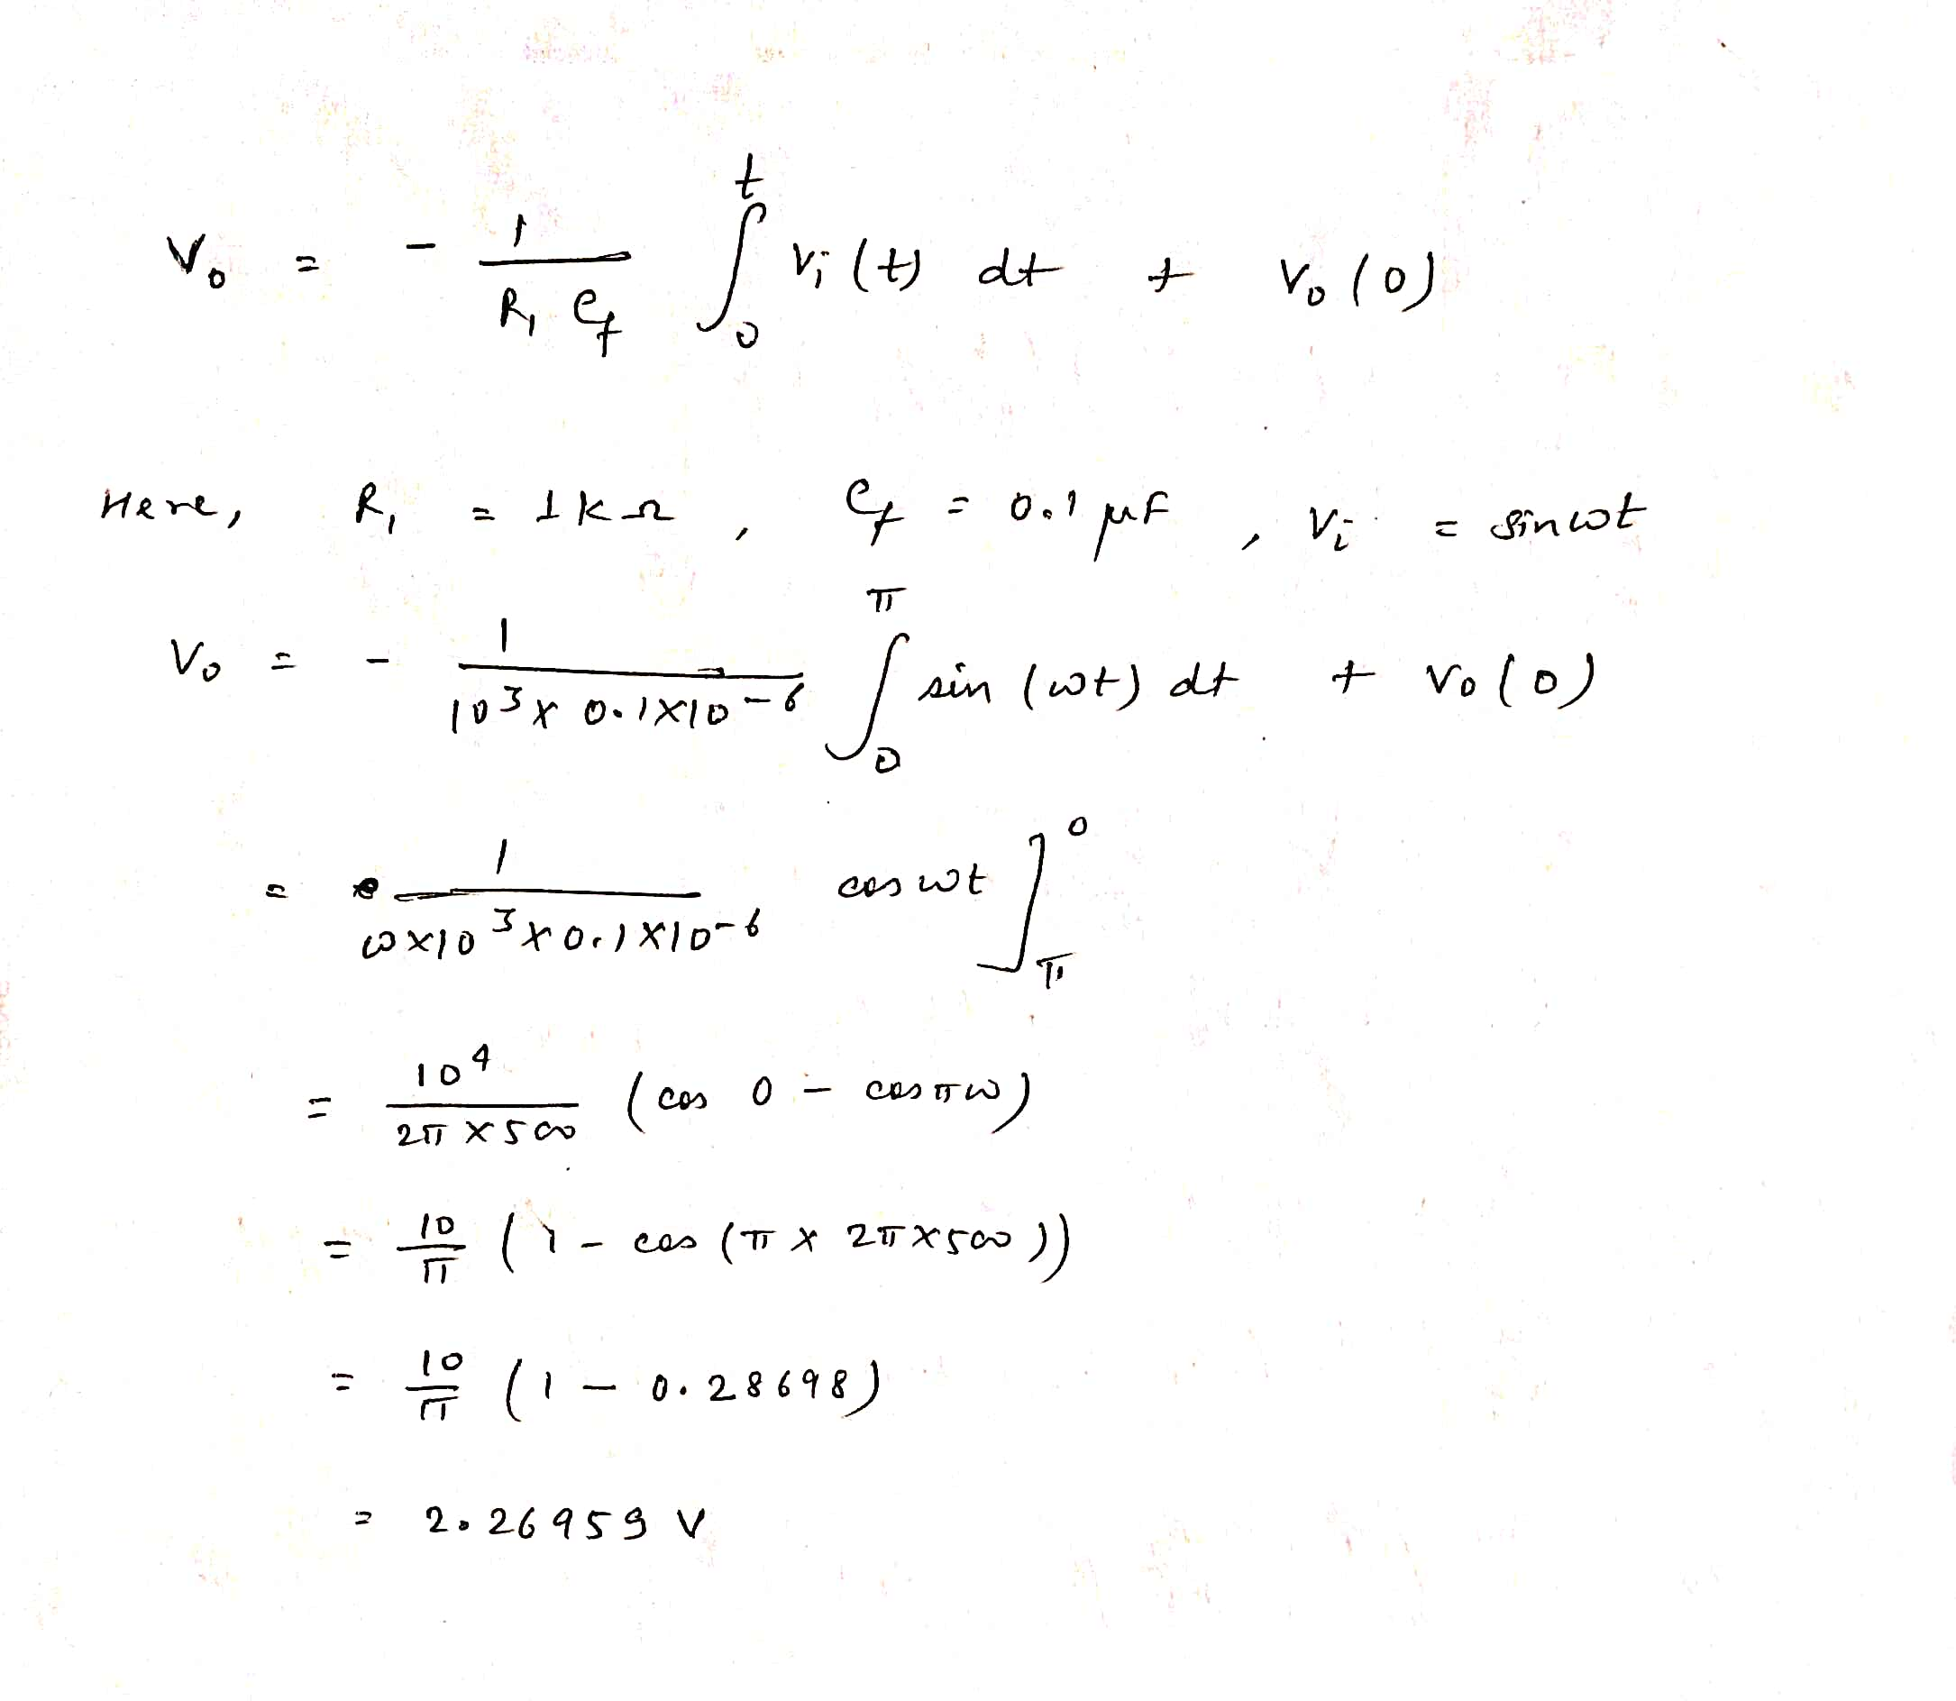

**RESULT:**

Integrator was designed using multisim , simulated and verified.